Student worksheet

8.3 Endothermic reactions absorb heat from the surroundings. Exothermic reactions release energy

Pages 160–161 and 224

Exothermic and endothermic reactions

1 What is an exothermic reaction?

2 What does exothermic mean?

3 Explain the amount of energy in reactants and products in an exothermic reaction. Draw a graph to help you.

|  |
| --- |
|  |

4 What is an endothermic reaction?

5 What does endothermic mean?

6 Explain the amount of energy in reactants and products in an endothermic reaction. Draw a graph to help you.

|  |
| --- |
|  |

7 Give an example of an exothermic reaction and how it is used in the real world.

8 Give an example of an endothermic reaction and how it is used in the real world.

Extend your understanding

Hydrogen (H2) and oxygen (O2) have 0kJ of energy. In order to break their bonds and form water, 1370kJ of energy is required. Once these bonds have been broken, the atoms rearrange to form water which contains -572kJ of energy.

9 On the graph below, draw the process of hydrogen (H2) and oxygen (O2) breaking their bonds to form water.

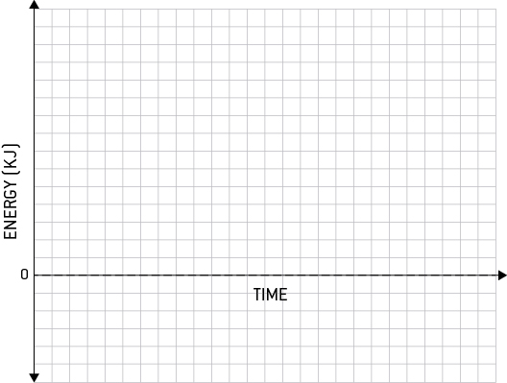

10 Catalysts are used to help a chemical reaction to occur faster. After introducing a catalyst, the energy required to break the bonds of hydrogen (H2) and oxygen (O2) lowers from 1370kJ to 500kJ. On the graph you drew above, draw a second process of hydrogen (H2) and oxygen (O2) forming water with a catalyst.